Cross-shaped polyhedron
# Source: AI Source: Provided by: [Data Path: Persons Table -> ID Column: 1, Name_En Column: Motasem Essam] -> From: [ChatGPT] on [7/25/2026]
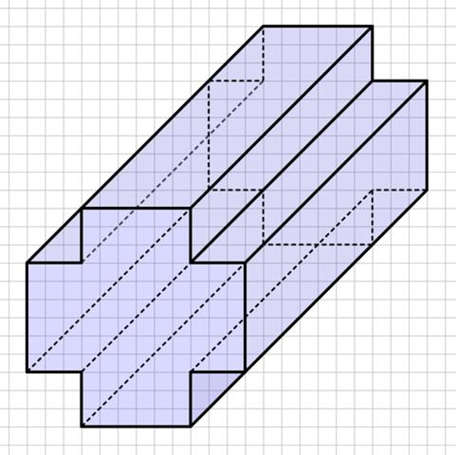
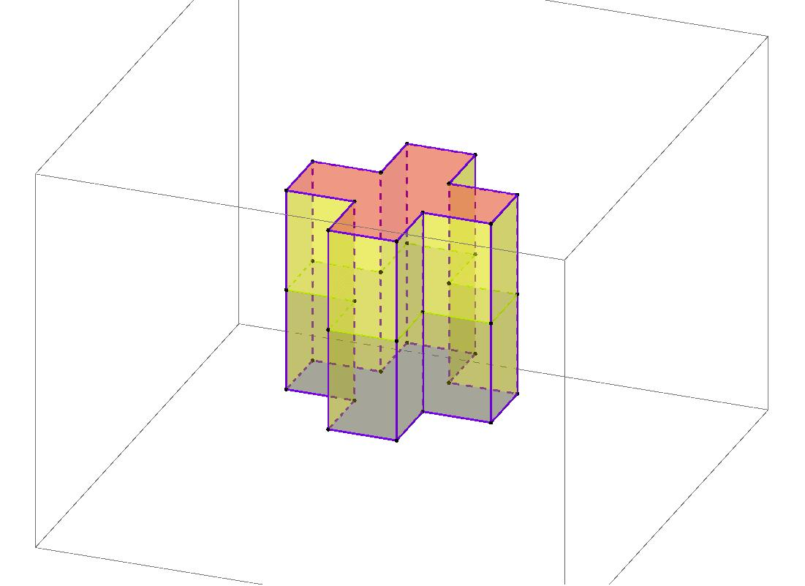
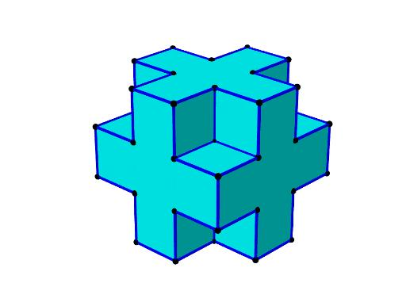

Definition
# Source: AI Source: Provided by: [Data Path: Persons Table -> ID Column: 1, Name_En Column: Motasem Essam] -> From: [ChatGPT] on [7/25/2026]
A cross-shaped polyhedron is a three-dimensional polyhedron whose overall form resembles a cross or plus sign when viewed from a particular direction. A common construction is a cross-shaped prism, created by extending a cross-shaped polygon uniformly into the third dimension.
When the cross-shaped polygon has inward corners, the resulting prism is a concave polyhedron. Its boundary consists of flat polygonal faces joined along straight edges.
The term describes a family of shapes rather than one uniquely defined polyhedron. The exact dimensions, number of faces, and number of vertices depend on the cross-shaped base and the construction.

Simple Definition
# Source: AI Source: Provided by: [Data Path: Persons Table -> ID Column: 1, Name_En Column: Motasem Essam] -> From: [ChatGPT] on [7/25/2026]
A cross-shaped polyhedron is a solid with flat faces that resembles a three-dimensional cross and typically contains inward corners.

Key Characteristics
# Source: AI Source: Provided by: [Data Path: Persons Table -> ID Column: 1, Name_En Column: Motasem Essam] -> From: [ChatGPT] on [7/25/2026]
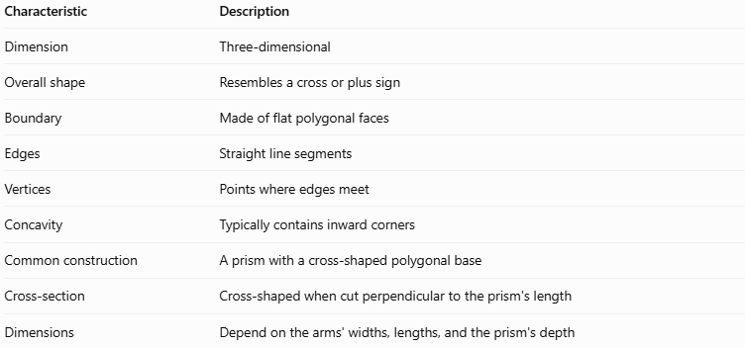
Characteristic | Description
Dimension | Three-dimensional
Overall shape | Resembles a cross or plus sign
Boundary | Made of flat polygonal faces
Edges | Straight line segments
Vertices | Points where edges meet
Concavity | Typically contains inward corners
Common construction | A prism with a cross-shaped polygonal base
Cross-section | Cross-shaped when cut perpendicular to the prism's length
Dimensions | Depend on the arms' widths, lengths, and the prism's depth

Geometric Representation
# Source: AI Source: Provided by: [Data Path: Persons Table -> ID Column: 1, Name_En Column: Motasem Essam] -> From: [ChatGPT] on [7/25/2026]
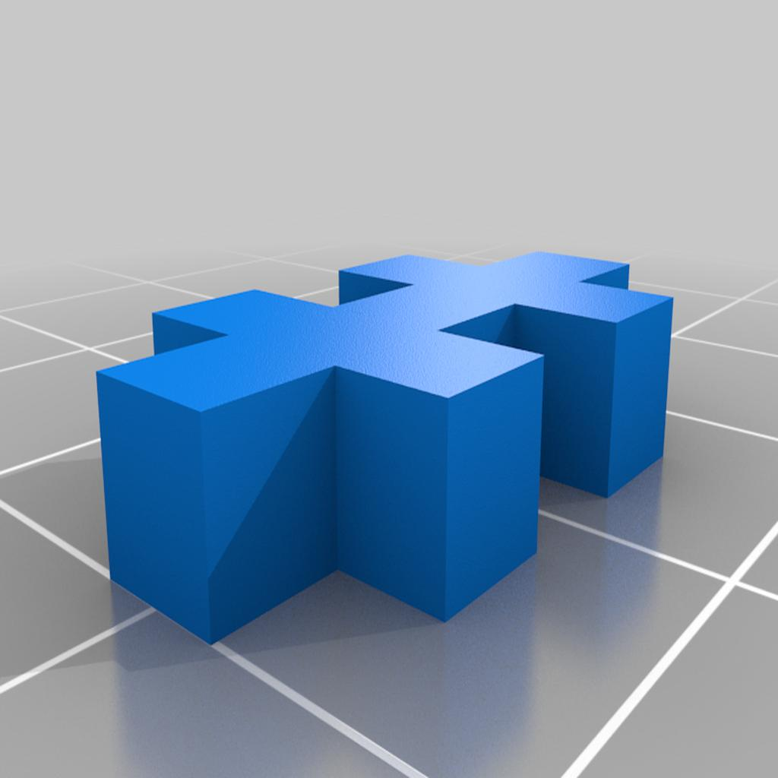
A common cross-shaped prism can be constructed from a plus-shaped polygon consisting of five equal squares: one central square and four squares attached to its sides.
Its main components are:
- Cross-shaped bases: Two congruent, parallel cross-shaped polygons.
- Lateral faces: Rectangular faces connecting corresponding edges of the bases in a right prism.
- Lateral edges: Straight edges connecting corresponding vertices of the two bases.
- Inner corners: Recessed corners between the arms of the cross.
- Arms: The projecting sections extending from the central region.

Mathematical Properties and Formulas
# Source: AI Source: Provided by: [Data Path: Persons Table -> ID Column: 1, Name_En Column: Motasem Essam] -> From: [ChatGPT] on [7/25/2026]
Consider a right cross-shaped prism whose base is a plus-shaped polygon formed from five equal squares.
Let:
- $a$ = side length of each small square
- $h$ = length of the prism
- $B$ = area of the cross-shaped base
- $P$ = perimeter of the cross-shaped base

Base Area
# Source: AI Source: Provided by: [Data Path: Persons Table -> ID Column: 1, Name_En Column: Motasem Essam] -> From: [ChatGPT] on [7/25/2026]
The base contains five equal squares:
$$B=5a^{2}$$

Base Perimeter
# Source: AI Source: Provided by: [Data Path: Persons Table -> ID Column: 1, Name_En Column: Motasem Essam] -> From: [ChatGPT] on [7/25/2026]
The cross-shaped base has 12 outer edges, each of length $a$:
$$P=12a$$

Volume
# Source: AI Source: Provided by: [Data Path: Persons Table -> ID Column: 1, Name_En Column: Motasem Essam] -> From: [ChatGPT] on [7/25/2026]
$$V=Bh$$
Therefore,
$$\boxed{V=5a^{2}h}$$

Lateral Surface Area
# Source: AI Source: Provided by: [Data Path: Persons Table -> ID Column: 1, Name_En Column: Motasem Essam] -> From: [ChatGPT] on [7/25/2026]
For a right prism, the lateral surface area is the base perimeter multiplied by the prism length:
$$A_{L}=Ph$$
Therefore,
$$\boxed{A_{L}=12ah}$$

Total Surface Area
# Source: AI Source: Provided by: [Data Path: Persons Table -> ID Column: 1, Name_En Column: Motasem Essam] -> From: [ChatGPT] on [7/25/2026]
$$A_{T}=2B+Ph$$
Substituting the base area and perimeter gives:
$$\boxed{A_{T}=10a^{2}+12ah}$$

Number of Faces, Edges, and Vertices
# Source: AI Source: Provided by: [Data Path: Persons Table -> ID Column: 1, Name_En Column: Motasem Essam] -> From: [ChatGPT] on [7/25/2026]
The plus-shaped base formed from five squares has 12 sides. For a prism with an $n$-sided polygonal base:
$$F=n+2, E=3n, V_{e}=2n$$
With $n=12$:
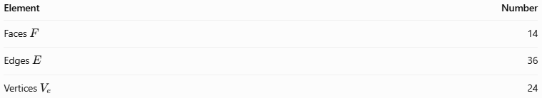
Element | Number
Faces $F$ | 14
Edges $E$ | 36
Vertices $V_{e}$ | 24
Euler's formula verifies these counts:
$$V_{e}-E+F=24-36+14=2$$
These counts apply to this particular cross-shaped prism, not every possible cross-shaped polyhedron.

Worked Examples
# Source: AI Source: Provided by: [Data Path: Persons Table -> ID Column: 1, Name_En Column: Motasem Essam] -> From: [ChatGPT] on [7/25/2026]
Example 1: Calculating the Volume
A cross-shaped prism has a base formed from five equal squares, each with side length $2\text{ cm}$. The prism's length is $5\text{ cm}$.
Step 1 — Calculate the base area.
$$B=5a^{2}=5\left(2^{2}\right)=20{\text{ cm}}^{2}$$
Step 2 — Calculate the volume.
$$V=Bh=20×5$$
$$\boxed{V=100{\text{ cm}}^{3}}$$
Example 2: Calculating the Total Surface Area
Using the same prism, where $a=2\text{ cm}$ and $h=5\text{ cm}$:
Step 1 — Calculate the base perimeter.
$$P=12a=12\left(2\right)=24\text{ cm}$$
Step 2 — Calculate the lateral surface area.
$$A_{L}=Ph=24×5=120{\text{ cm}}^{2}$$
Step 3 — Calculate the total surface area.
$$A_{T}=2B+A_{L}$$
$$A_{T}=2\left(20\right)+120$$
$$\boxed{A_{T}=160{\text{ cm}}^{2}}$$

Comparison with Related Concepts
# Source: AI Source: Provided by: [Data Path: Persons Table -> ID Column: 1, Name_En Column: Motasem Essam] -> From: [ChatGPT] on [7/25/2026]
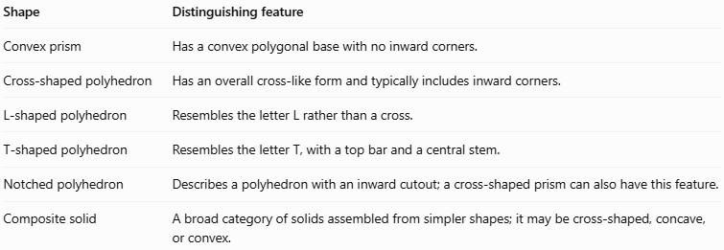
Shape | Distinguishing feature
Convex prism | Has a convex polygonal base with no inward corners.
Cross-shaped polyhedron | Has an overall cross-like form and typically includes inward corners.
L-shaped polyhedron | Resembles the letter L rather than a cross.
T-shaped polyhedron | Resembles the letter T, with a top bar and a central stem.
Notched polyhedron | Describes a polyhedron with an inward cutout; a cross-shaped prism can also have this feature.
Composite solid | A broad category of solids assembled from simpler shapes; it may be cross-shaped, concave, or convex.

Constructing Cross-shaped polyhedron in Solid Geometry

Instruments Used
# Source: AI Source: Provided by: [Data Path: Persons Table -> ID Column: 1, Name_En Column: Motasem Essam] -> From: [ChatGPT] on [7/25/2026]
The construction is performed using traditional geometric drawing instruments.
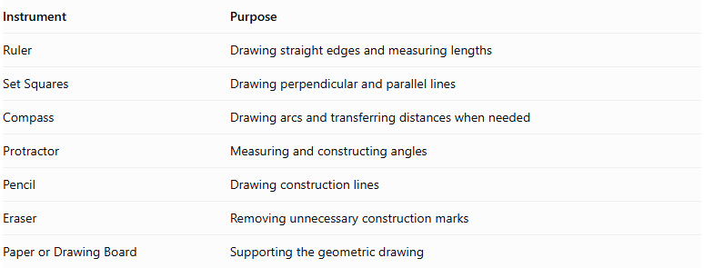
Instrument | Purpose
Ruler | Drawing straight edges and measuring lengths
Set Squares | Drawing perpendicular and parallel lines
Compass | Drawing arcs and transferring distances when needed
Protractor | Measuring and constructing angles
Pencil | Drawing construction lines
Eraser | Removing unnecessary construction marks
Paper or Drawing Board | Supporting the geometric drawing

Construction Procedures

Addition-Based Construction
# Source: AI Source: Provided by: [Data Path: Persons Table -> ID Column: 1, Name_En Column: Motasem Essam] -> From: [ChatGPT] on [7/25/2026]
- Determine the dimensions of the central region and the four arms.
- Draw the central rectangular component.
- Draw the horizontal arm components extending from the central region.
- Draw the vertical arm components.
- Join the components without leaving gaps or creating unintended overlaps.
- Extend the cross-shaped outline through the required depth.
- Draw the visible lateral faces.
- Add the remaining edges and refine the final solid representation.

Subtraction-Based Construction
# Source: AI Source: Provided by: [Data Path: Persons Table -> ID Column: 1, Name_En Column: Motasem Essam] -> From: [ChatGPT] on [7/25/2026]
- Begin with a suitable rectangular prism or larger solid.
- Determine the portions that must be removed.
- Mark the removal boundaries using a ruler and set squares.
- Draw the required cutting boundaries.
- Represent the removed regions.
- Complete the remaining cross-shaped solid.
- Draw the visible faces, edges, and recessed regions.

Cross-Section-Based Construction
# Source: AI Source: Provided by: [Data Path: Persons Table -> ID Column: 1, Name_En Column: Motasem Essam] -> From: [ChatGPT] on [7/25/2026]
- Draw the cross-shaped polygon that will form the cross-section.
- Divide the outline into a central region and four arms if necessary.
- Ensure that the boundaries are connected and form a closed polygon.
- Draw a second congruent cross-shaped polygon at the required depth.
- Connect corresponding vertices of the two polygons.
- Complete the lateral faces.
- Distinguish visible and hidden edges.

Face-Based Construction
# Source: AI Source: Provided by: [Data Path: Persons Table -> ID Column: 1, Name_En Column: Motasem Essam] -> From: [ChatGPT] on [7/25/2026]
- Determine the polygonal faces required for the solid.
- Draw the front cross-shaped face.
- Draw the corresponding rear face.
- Connect matching boundary vertices.
- Construct the lateral faces.
- Refine the edges and visible surfaces.

Net-Based Construction
# Source: AI Source: Provided by: [Data Path: Persons Table -> ID Column: 1, Name_En Column: Motasem Essam] -> From: [ChatGPT] on [7/25/2026]
- Determine the cross-shaped base polygon.
- Draw the lateral faces around its boundary.
- Attach a second congruent cross-shaped polygon to an appropriate lateral face.
- Check that the faces are connected along matching edges.
- Cut out the net.
- Fold along the edges and join the corresponding boundaries to form the solid.
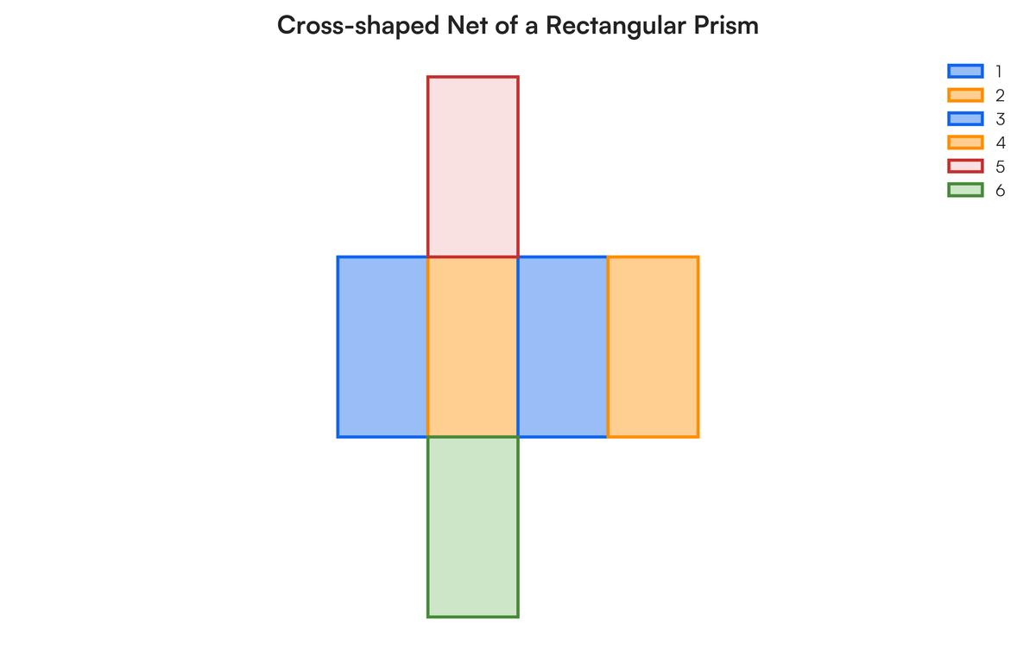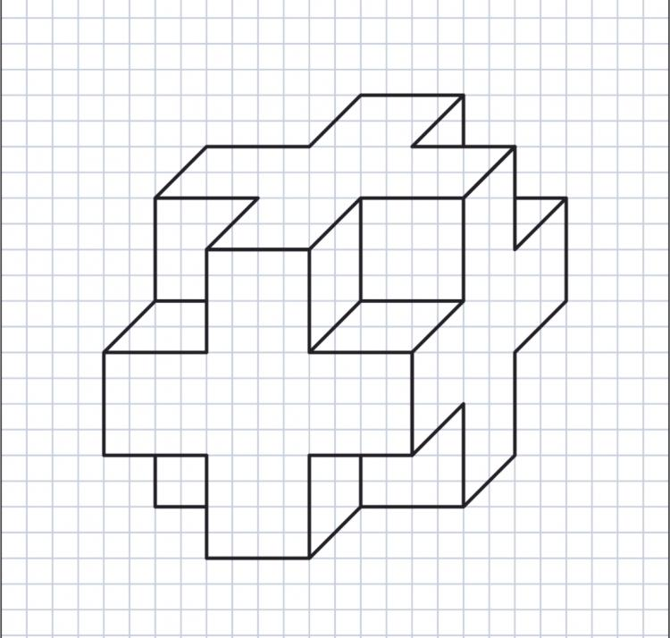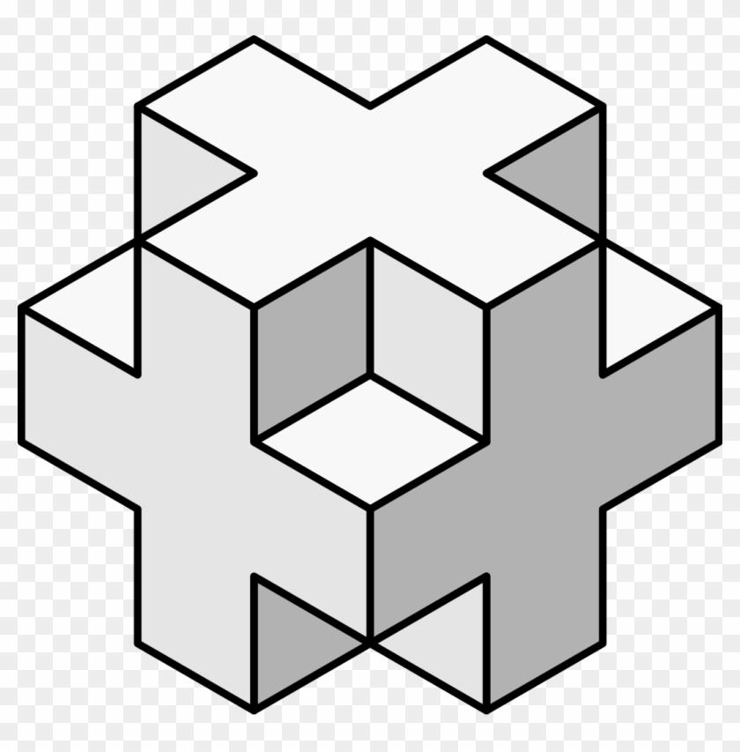

Applications
# Source: AI Source: Provided by: [Data Path: Persons Table -> ID Column: 1, Name_En Column: Motasem Essam] -> From: [ChatGPT] on [7/25/2026]
- Architecture: Modeling cross-shaped buildings and floor plans.
- Construction: Calculating the volume of cross-shaped concrete sections.
- Engineering: Designing structural supports and intersecting components.
- Manufacturing: Representing cross-shaped bars and mechanical parts.
- Computer graphics: Creating and rendering concave three-dimensional models.
- Geometry education: Exploring polygonal bases, prisms, surface area, and volume.

Key Points
# Source: AI Source: Provided by: [Data Path: Persons Table -> ID Column: 1, Name_En Column: Motasem Essam] -> From: [ChatGPT] on [7/25/2026]
- A cross-shaped polyhedron resembles a cross or plus sign from a particular viewpoint.
- A common example is a prism with a cross-shaped concave polygon as its base.
- A plus-shaped base made from five equal squares has 12 sides.
- Its corresponding right prism has 14 faces, 36 edges, and 24 vertices.
- The volume of the prism equals its base area multiplied by its length.
- Its total surface area is $2B+Ph$.
- The term describes a family of shapes; not every cross-shaped polyhedron has the same dimensions or element counts.

Conclusion
# Source: AI Source: Provided by: [Data Path: Persons Table -> ID Column: 1, Name_En Column: Motasem Essam] -> From: [ChatGPT] on [7/25/2026]
A cross-shaped polyhedron is a three-dimensional geometric solid characterized by its cross-like appearance and, in the common prism construction, its concave polygonal base. It provides a useful example for studying concave polyhedra, counting faces and edges, and calculating volume and surface area.

